SDP

A PROJECT REPORT

ON

EVENT MANAGEMENT SYSTEM

**GROUP MEMBERS**

|  |  |  |
| --- | --- | --- |
| **1.** Akshay Kumar | - | 1641012305 |
| **2.** Anuj Kumar | - | 1641012226 |



**DEPARTMENT OF COMPUTER SCIENCE & ENGINEERING**

**Institute of Technical Education & Research**

**SIKSHA ‘O’ ANUSANDHAN DEEMED TO BE UNIVERSITY**

**Bhubaneswar, Odisha, India**

# ACKNOWLEDGEMENT

It is matter of great pleasure for us to get this opportunity expressing our sincere sense of gratitude to Siksha ‘O’ Anusandhan Deemed to be University. Firstly, we would like to express our heartily thanks to Institute of Technical Education & Research for providing lab facility & other relevant facilities. Our guide **Dr. Sambit Kumar Mishra** was the main force behind all these efforts. Because of his valuable suggestions & proper guidance for this project. We express our sincere thanks to the Computer Science & Engineering department HOD **Dr. Debahuti Mishra** who had allowed us to use facilities of the institute. We are also thankful to all those who have helped us in this endeavor either directly or indirectly especially all our teachers. At last we would like to express a big thank you to all friends & all known & unknown person who had helped us directly or indirectly.

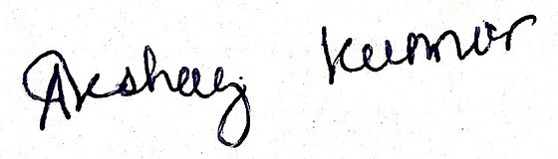

**Place: Odisha, Bhubaneswar Signaature of Students:**

# CERTIFICATE

This is to certify that the project report titled “Event Management System” being submitted by **Akshay Kumar, Anuj Kumar** of CSE section **G** to the Institute of Technical Education & Research, Siksha ‘O’ Anusandhan Deemed to be University, Bhubaneswar for the partial fulfillment for the degree of Bachelor of Technology in Computer Science & Engineering is a record of original confide work carried out by them under my supervision & guidance. The project work, in my opinion, has reached the requisite standard fulfilling the requirements for the degree of Bachelor of Technology.

The application developed for this project work have not been submitted in part or full to any other University or Institute for the award of any degree or diploma.

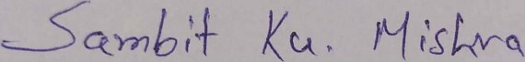

Dr. Sambit Kumar Mishra

Computer Science Department ITER, SOA Deemed to be University

**DECLARATION**

We declare that this written submission represents our ideas in our own words & where other‟s ideas or words have been included, we have adequately cited & referenced the original sources. We also declare that we have adhered to all principles of academic honesty & integrity & have not misrepresented or fabricated or falsified any idea/fact/source in our submission. We understand that any violation of the above will be cause for disciplinary action by the University & can also evoke penal action from the sources which have thus not been properly cited or from whom proper permission has not been taken when needed.

**Signature of students with regd. numbers :**

(1641012305)

(1641012226)

**Date:**

17/05/2020

**CONTRIBUTION OF INDIVIDUAL**

**TEAM MEMBERS**

|  |  |  |
| --- | --- | --- |
| **Name of the Student(s)** | **Registration No.** | **Contribution** |
| Akshay Kumar | 1641012305 | 1. Front-end part of the complete application (Html, CSS, Javascript). 2. The database of the Application (Maria-DB). 3. Report development. |
| Anuj Kumar | 1641012226 | 1. Back-end part of the complete Apllication (PHP). 2. The testing of the Applicaton (Unit & Integration testing). 3. Report development. |

Note: Both the Student(s) contributed equally towards report development. Hence,

No primary contributor(s).

## SYNOPSIS OF PROJECT

The objective of the EMS website is to manage the details of the Events, Users, Booking Events, Locations. It manages all the information about Events, their Locations & Enquiry.

The project is built & designed at the administrative end & thus only the administrator with authenticated user id and password is guaranteed access. The primary purpose of the EMS project is to build a website to minimize the manual labour for managing the Events, their Locations, & Customer Support all in one place. All the details about the Event, the Date, and the location is tracked by the EMS.

System very efficiently stores, maintains & retrieves data from the MariaDB database & can be used for further analysis if required. All the latest notifications are provided to its user and also the user can follow EMS on all social platforms from the footer of the website.

The data is securely stored to the MariaDB databse that is available the event organizer. As the database is based on SQL it is easy to manage the data in the MariaDB database. Participants can register for any upcoming events from anywhere around the globe. The event organizer has the records of participants and can view the details as and when required.

## QUESTIONNAIRE

Q1. When organizing an event, which process is most suitable for you?

1. A web-based system where the location and time slot is chosen and booked accordingly.
2. Going to an Event Management Company have a long talk with them, and then confirm the location and time.
3. Both of the above options are fine, I don’t have any problem

Q2. What do you think is the major advantage of an online EMS and an offline one?

1. Bargaining for the price of the venue.
2. Not having any prior information about the availability of the venue.
3. I think Offline Event Management Offices are better.

### Question-1:

OptionA: 70%

OptionB: 20%

OptionC: 10%

OptionA OptionB OptionC

### Question-2:

OptionA: 60%

OptionB: 30%

OptionC: 10%

OptionA OptionB OptionC

## ANALYSIS OF THE SURVEY

### Existing Event Management System

* + In the existing EMS, the customer has to manually visit the EMS office for inquiry.
  + The existing EMS’s process is little complex & also a manual one.
  + The EMS has to keep records of all the events manually.

### Disadvantages of Existing System

* + It consumes a lot of time for the customer and the Administrator.
  + The paperwork results in a lot of physical space to keep the data.
  + Lack of security and privacy.
  + It has chances of errors that are hard to be identified.

### Advantages of the New System

* + It is easy to use & faster to implement than traditional EMS.
  + It is a web-based & easy to access their information anywhere on any device.
  + It helps to control problems that usually occur in any event.
  + Quick & easy registration for the participants.
  + Automatic confirmation emails.
  + Online data submission is secured dual time.
  + Real-time reports.
  + Saves time.
  + It helps in checking the appointment of a particular venue.
  + It also helps to check & know the target audience.
  + User friendly.

**TABLE OF CONTENTS**

TITLE PAGE

CERTIFICATE

DECLARATION

CONTRIBUTION OF INDIVIDUAL TEAM MEMBERS

SYNOPSIS

QUESTIONNAIRE

ANALYSIS OF THE SURVEY

1. **INTRODUCTION**
   1. PREFACE
   2. PROBLEM DEFINITION
   3. OBJECTIVE
   4. OVERVIEW
   5. SOFTWARE SPECIFICATIONS
   6. HARDWARE SPECIFICATIONS
   7. ORGANIZATION OF THE REPORT
2. **LITERATURE SURVEY**
   1. PREFACE
   2. EXISTING SYSTEM
   3. PROPOSED SYSTEM
   4. FEASIBILITY STUDY
3. **SYSTEM ANALYSIS & DESIGN**
   1. PREFACE
   2. REQUIREMENT SPECIFICATION
      1. FUNCTIONAL REQUIREMENTS
      2. NON FUNCTIONAL REQUIREMENTS
   3. UML DIAGRAMS
      1. USE CASE DIAGRAM
      2. CLASS DIAGRAM
      3. SEQUENCE DIAGRAM
      4. STATE DIAGRAM
4. **TESTING**
   1. UNIT TESTING
   2. INTEGRATION TESTING
5. **RESULTS & DISCUSSIONS**
   1. PREFACE
   2. USER INTERFACE
      1. LAYOUT DESIGNS
      2. TABLE & DATABASE DESIGN
      3. SERVER & DATABASE CONFIGURATIONS
6. **SOCIO ECONONMIC ISSUES**
   1. PRACTICE RELEVANCE
   2. GLOBAL IMPACT
   3. LIFELONG LEARNING
7. **CONCLUSION & FUTURE SCOPE**
   1. CONCLUSION
   2. FUTURE SCOPE
8. **TAKE-AWAY FROM THE PROJECT**

8.1 REFERENCES

8.2. SIMILARITY REPORT

8.3. MAPPING OF PO’S AND PSO’S TO EVIDENCES

## INTRODUCTION

### PREFACE

Event management is the application of project management to the Creation & Development of large scale events such as festivals, Wedding ceremonies, formal parties. People that are needed to find or book online event halls & or willing to see the packages & timing slots online about halls. They will able to get all this information through this system. To get success in the event management business, a user should have strong network contacts of the service providers. These contacts are essentially providers of specific services who can be mobilized quickly to participate in any given event. To make an event successful event Manager needs different service providers like Sound systems services, Lighting providers, Canteen services, stage construction & so on.

**PROBLEM DEFINITION**

Develop a web application which facilitates the users to book for

an event, host an event, look out for the venues, select the venues

for their event as available. This system would be helpful for the

event management companies to manage their paper work online

and retrieve reports of completed events, without having to deal

massive amounts of paperwork.

### OBJECTIVE

The main objective of this website is to store, maintain & retrieve data from its database & can be used for further analysis. This system provides the latest notification to its user. Time-saving activity. The data in a centralized way that is available to all the event managers. Easy to manage historical data in the database. Participants can register for any happening event from anywhere. The Event manager can keep records of participants.

**OVERVIEW**

This project Event Management System serves the functionality of an event manager. This system allows any user to see what are the upcoming events and only registered users can book for an event and add an event. Once the user enters an event type i.e Marriage, Birthday, Magic Show etc, the system allows to select date and time of the event, location and the events description. All the data is then stored into the database and is sent to the administrator. The user gets all the resources at a single instead of wandering around. The system is effective and saves time.

**SOFTWARE SPECIFICATIONS**

* Languages: HTML, JavaScript, PHP.
* API’s & Frameworks: CSS, Bootstrap, Jquery.
* Database: MariaDB.
* Server: Wamp (LocalHost).
* IDE: Netbeans
* Browser: Google Chrome.

### HARDWARE SPECIFICATIONS

To be able to run the system, the minimum requirements of the hardware for this system are:

CPU: 2.0 GHz

RAM: 2 GB LPDDR2 HDD: 60 GB

The hardware used must have a competent firewall to secure the data in the system.

**ORGANIZATION OF THE REPORT**

This report is presented and materialized into 8 sections. After the introductory part, section 2 describes literature survey which defines the proposed system and provides feasibility study.

Section 3 describes the system analysis and design which talks about the specifications and defines the work using diagrams. Section 4 is the testing section where all the testing performed have been mentioned. Section 5 describes the results and provides with helpful discussions regarding the project work, layout designs, user interface, database design and the outputs of the complete project work. Section 6 is an elongated study about how the project impacts real life scenarios, its relevance and the learning it subsides. Section 7 is the conclusion and the future scopes of the project. Finally, Section 8 are the references we took to design and develop our project.

### SCOPE

System very efficiently stores, maintain & retrieve data from its database & can be used for further analysis. Time-saving activity. The data in a centralized way that is available to all the event managers. Easy to manage historical data in the database.

Participants can register for any happening event from anywhere. The Event manager can keep records of participants.

### DEFINITION, ACRONYMS & ABBREVIATIONS

Definitions & Acronyms Provide definitions or references to all the definitions of the special terms & acronyms used within this document

EMS: Event Management System DFD: Data flow diagram

RID: Requirements ID

Web-based application: An application that runs on the Internet.

MariaDB: MariaDB Server is one of the most popular

open-source relational databases made by the developers of MySQL & guaranteed to stay open-source. It is part of most cloud offerings & default in most Linux distributions.

## LITERATURE SURVEY

### PREFACE

This system is completely computerized and has been developed using advanced language. It is a web application. As with growing technologies and advanced mechanisms and automations developed for ease of life. This is a completely new approach to how we manage events manually and transforming it into a dynamically maintained website. The website will be a new independent product, i.e. it is not a component of another program. It is intended for the administration of the management & other concerned users. The product will import its data from My SQL Database & use the PHP for its integrated development environment. This information can be accessed by the users aside from the developers. All the forms used in the product follows a clear & logical structure. Errors will be minimized through the use of drop-down buttons & command buttons to eliminate the excessive use of text input. Management of data includes searching, adding, modifying & deleting.

**EXISTING SYSTEM**

In the existing system, the user or the customer has to visit the particular office or hotel (where event has to take place) for enquiry. The user has to manually look out for the booking dates and the whole process is quite complicated and a lot of hours of work are needed to be put in for the successful execution of the event and all of it needs to be done completely manually. The record of events has to be maintained by the system manually as well. It consumes a lot of the time of the user or the customer or the event manager as well. For most of the part, paperwork has to maintained properly without any fault which results in a lot of space to keep the data. Security issues can be concern in this existing system. And the chances or the probability of human errors increases with this manual style of working and can cause lots of issues.

### PROPOSED SYSTEM

It shall perform the following functions:

* + - Protect the database of the firm by requiring a correct & registered username & password.
    - Facilitate a step-by-step process of entering, organizing, retrieving, modifying & deleting data from the database without the need to go to the database itself.
    - Add new client information easily.
    - Provide an option for users to update information such as location or venue or any other details of their event.
    - Delete existing event information.
    - Present a list of upcoming events & trending locations without the need of a user to login.
    - Display personalized locations & events after the registered user logs in.

**FEASIBILITY STUDY**

Event Management is considered a strategic marketplace and communication tools by organizations worldwide. From product launches to press conferences to weddings to talk shows and the audience is targeted through social networks or news media. One of the major aspects is to impart a variety of optional models such as the following:

* Setting out aims or objectives.
* Time and place selection.
* Logistics applied.
* Revenue generation.
* Risk assessments.
* Assessment of various other similarities.
* Alternate options or models.

## SYSTEM ANALYSIS AND DESIGN

### PREFACE

### This section dealing with the system analysis and design of the project

### Event Management System provides us with the most modern

### approach to deal with event handling which was a manual activity

### and digitalize using computerized ways. The system is analyzed into

### various sections and begins with the user interface where we have

### tried to make all functionalities as user friendly as possible to

### maneuver their way into the website as easily as possible. The

### requirements needed to successfully operate this website have

### been mentioned in the following sections. From searching to

### adding to viewing to deleting the specified events have all been

### listed about in analysis and design fields. The UML diagrams

### provide us with a much clearer view of how this system works.

### The system is to manage all activities and duties which are being

### Performed by various event conductors. This system is the planning

### of all the people, teams and features that come together how to

### create various kinds of events.

### USER INTERFACES

The interface of the software will provide options for relatively easy data input processes text-boxes that will be properly labeled. It will also have a user-friendly view of the whole system with a simple & easy undertaking of action-driven processes as command buttons are functionally labeled. With all these, target users of this software will relatively find it not difficult to use it.

### SOFTWARE INTERFACES

* Languages: HTML, JavaScript, PHP.
* API’s & Frameworks: CSS, Bootstrap, Jquery.
* Database: MariaDB.
* Server: Wamp (LocalHost).
* IDE: Netbeans
* Browser: Google Chrome.

### HARDWARE INTERFACES

To be able to run the system, the minimum requirements of the hardware for this system are:

CPU: 2.0 GHz

RAM: 2 GB LPDDR2 HDD: 60 GB

The hardware used must have a competent firewall to secure the data in the system.

### SAFETY REQUIREMENTS

Different information is entered into the database such as information about the different caterers, suppliers & participants. Mismanagement of information might cause participant dissatisfaction that will eventually lead to profit loss, only because of mistakes on giving information. In line with this, the organizer should always double- check which suppliers are available

### FUNCTIONAL REQUIREMENTS

* 1. Registration:
     + The user has to register himself first for a personalized experience of this EM system. The following are the mandatory requirements for registration: user’s first name, user’s last name, user name(chosen by user), user’s email- id, password(entered by the user), & confirm password(same as the password).
  2. User Login:
     + The facility to login to the EMS Website is provided by the system.
     + A registered username & password should be entered.
     + The user personal profile page is shown.

1. Add/Modify the Event:
   * The user can add the details of the event that he wants EMS to manage also multiple events could be added and modified if added already.
2. Venue Selection:
   * The registered user can select or change the venue of their event & date & time for booking the venue accordingly.
3. Logout:
   * The system provides the facility to logout from the site
   * Input: Select the logout option.
   * Output: Logout from the system.
   * Processing: User will be Logged out.

### NON FUNCTIONAL REQUIREMENTS

1. Performance Requirements:
   * The EMS needs to be reliable and robust
   * If the EMS is unable to process a request then an error message should be displayed corresponding to the request.
   * Website should be loaded within a fraction of seconds.
2. Safety Requirements:
   * All of the personal details need to be maintained properly and securely.
   * Before performing any action on the EMS the user must have been authenticated by the MariaDB.
   * The MariaDB database must have a backup.
3. Security Requirements:
   * On entering the registered user-id & the password the user can access his personal event details.
   * The details provided by the user must be safe and secured by bit encryption.
   * Each user must be able to edit only his/her events and locations.
4. Data Requirements:
   * Minimum 1GB HDD space is recommended for running the EMS software.
   * Minimum 512MB RAM is recommended to run EMS smoothly.
5. External Requirements:
   * To get related updates & important notifications through email, the user must register with a valid, working email address during the registration to EMS.

## UML DIAGRAMS

### USE CASE DIAGRAM

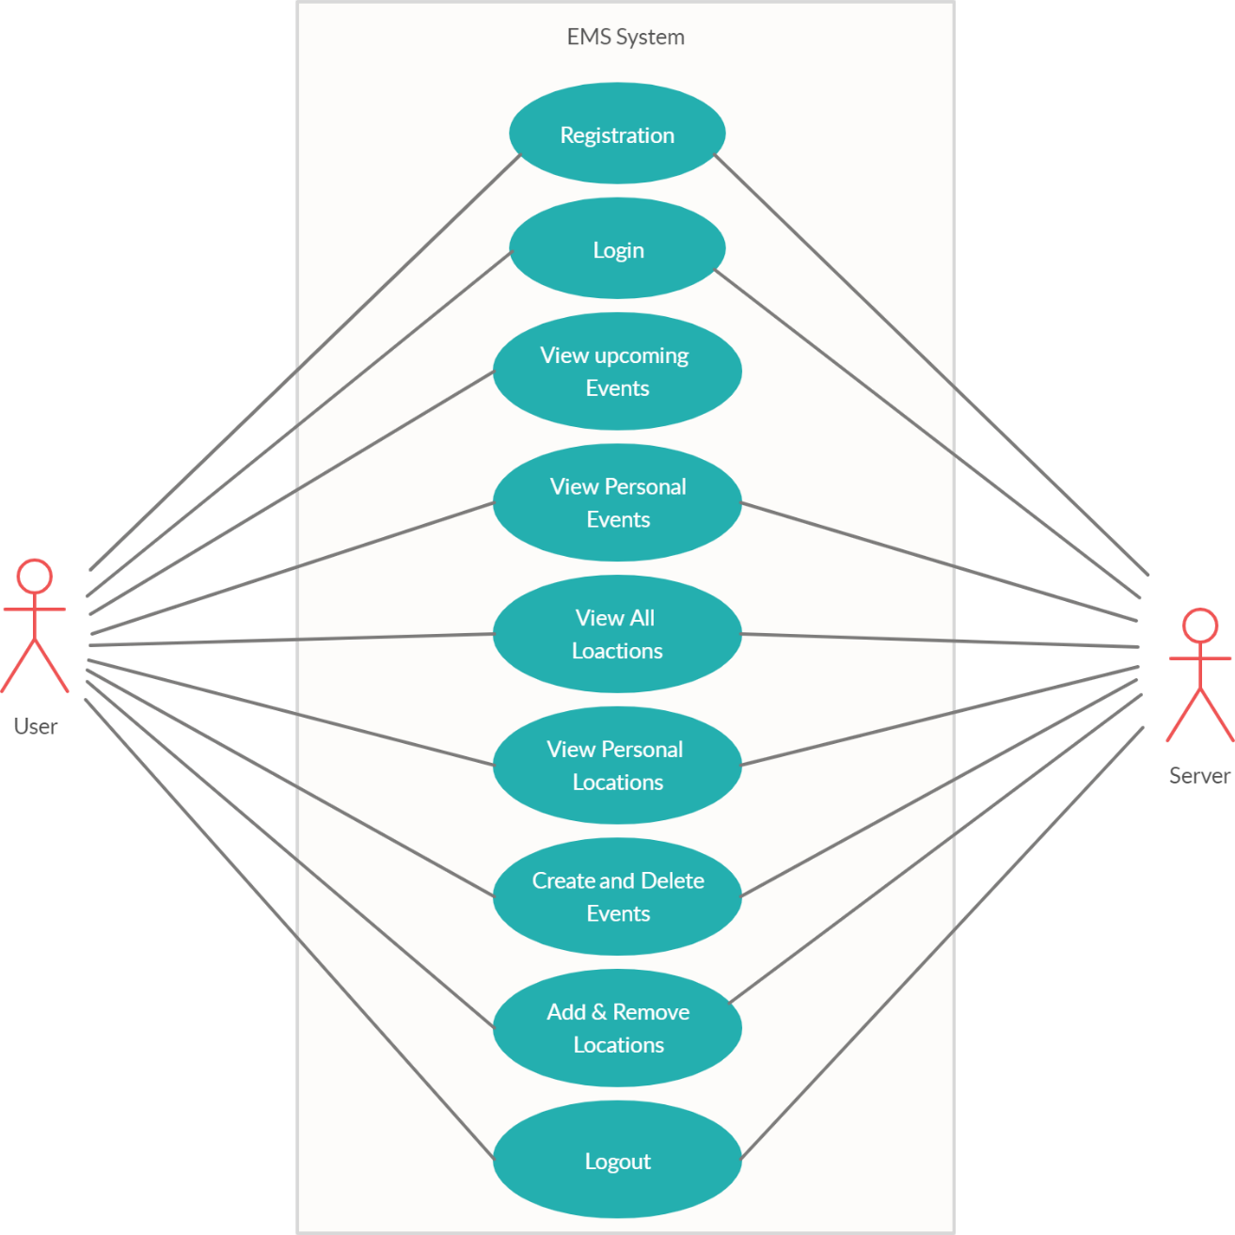

**CLASS DIAGRAM**

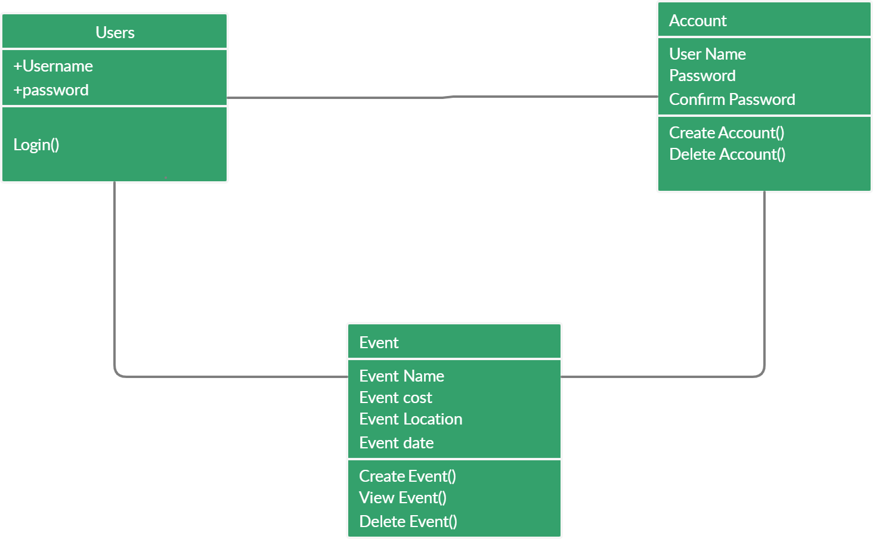

**SEQUENCE DIAGRAM**

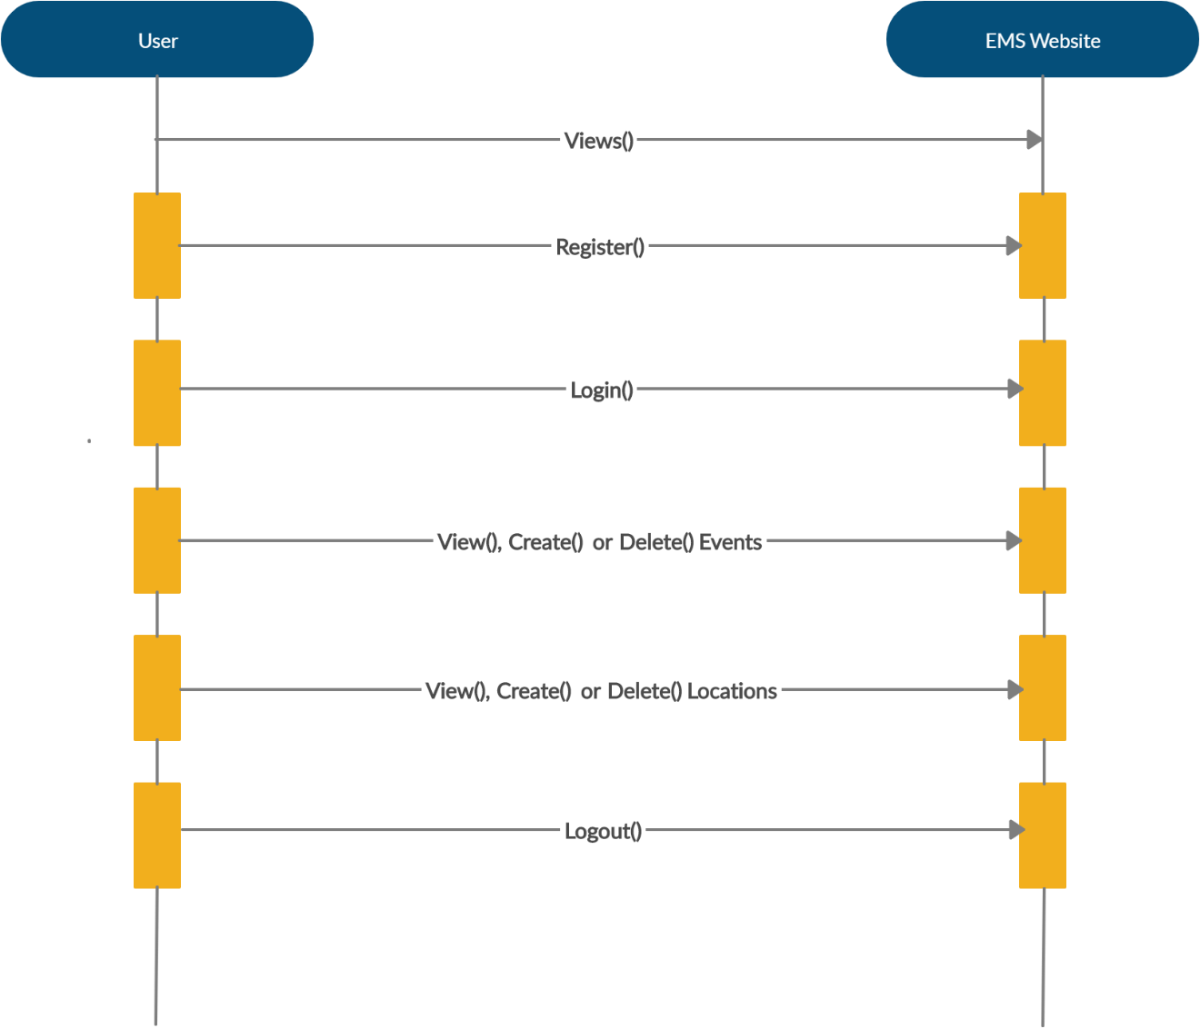

**STATE DIAGRAM**

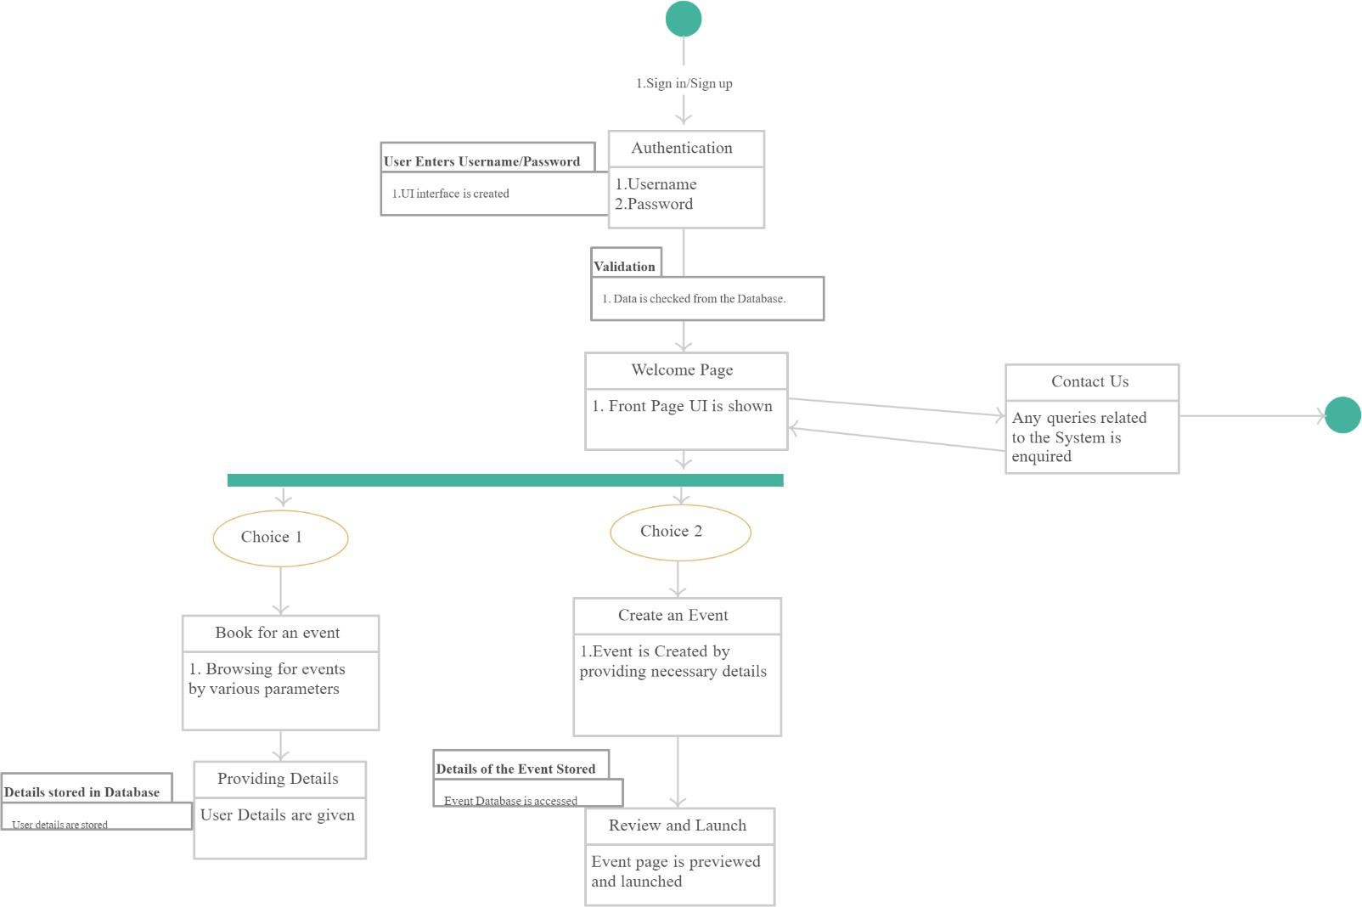

**TESTING**

UNIT TESTING

|  |  |  |  |  |  |  |
| --- | --- | --- | --- | --- | --- | --- |
| Test case id: | Test  Scenario: | Test Steps: | Test Data: | Expected results: | Actual results: | Pass/Fail |
| TCID  1 | Check user login with valid data | 1. Go to site 2. Enter user   id   1. Enter user password 2. Check submit | User id: akshay@ems.com  User password: ak123 | User should login into application. | As expected | Pass |

|  |  |  |  |  |  |  |
| --- | --- | --- | --- | --- | --- | --- |
| Test case id: | Test  Scenario: | Test Steps: | Test Data: | Expected results: | Actual results: | Pass/Fail |
| TCID2 | Check user login with invalid data | 1. Go to site 2. Enter user   id   1. Enter user password 2. Check submit | User id:  [akshay@ems.com](mailto:akshay@ems.com)  password:  ak123 | User should not login into application. | As expected | Pass |

|  |  |  |  |  |  |  |
| --- | --- | --- | --- | --- | --- | --- |
| Test case id: | Test  Scenario: | Test Steps: | Test Data: | Expected results: | Actual results: | Pass /Fail |
| TCID3 | Test the  Submit button. | 1. Go to site 2. Navigate to login/signup page. 3. Fill the form according to the format. 4. Click submit. | User name: Akshay Kumar  Email:akshay@ems.com Password: ak123 | The user can make new account on this web application | As expected | pass |

|  |  |  |  |  |  |  |
| --- | --- | --- | --- | --- | --- | --- |
| Test case id: | Test  Scenario: | Test Steps: | Test Data: | Expected results: | Actual results: | Pass/Fail |
| TCID  4 | Search for an event | 1. Go to site 2. Login using credentials 3. Go to events 4. See all upcoming events | User Id: akshay@ems.com  Password: ak123  Select from the available options. | User should check out for an event as he/she sees fit. | As expected | Pass |

|  |  |  |  |  |  |  |
| --- | --- | --- | --- | --- | --- | --- |
| Test case id: | Test  Scenario: | Test Steps: | Test Data: | Expected results: | Actual results: | Pass/Fail |
| TCID  5 | View event | 1. Go to site 2. Login using credentials 3. Go to events 4. Open and view an event | Event ID: 1  Title: Wedding  Start Date: 10-12-2020  End Date:  14-12-2020  Cost: 1500000  Location: Royals  (Only View) | User should be able to view any event of his/her choice. | As expected | Pass |

|  |  |  |  |  |  |  |
| --- | --- | --- | --- | --- | --- | --- |
| Test case id: | Test  Scenario: | Test Steps: | Test Data: | Expected results: | Actual results: | Pass/Fail |
| TCID  6 | Add an Event | 1. Go to site 2. Login using credentials 3. Go to Events 4. Add event | Location Id:1  Location Name: Royals  Address: Mumbai  Manager Name: Akshay Kumar  Manager Email: akshay@ems.com  Manager Phone no: 7835162882  Max Capacity: 100 | User should be able to add an event. | As expected | Pass |

|  |  |  |  |  |  |  |
| --- | --- | --- | --- | --- | --- | --- |
| Test case id: | Test  Scenario: | Test Steps: | Test Data: | Expected results: | Actual results: | Pass/Fail |
| TCID  7 | Modify an event | 1. Go to site 2. Login using credentials 3. Go to Events 4. Edit Events | Location Id:1  Location Name: Royals  Address: Mumbai  Manager Name: Akshay Kumar  Manager Email: akshay@ems.com  Manager Phone no: 7835162882  Max Capacity: 200 | User should be able to update an event. | As expected | Pass |

|  |  |  |  |  |  |  |
| --- | --- | --- | --- | --- | --- | --- |
| Test case id: | Test  Scenario: | Test Steps: | Test Data: | Expected results: | Actual results: | Pass/Fail |
| TCID  8 | Delete an event | 1. Go to site 2. Login using credentials 3. Go to Events 4. Edit Events 5. Actions: Select Delete | Select Actions: Delete (on the event to be deleted). | User should be able to delete an event. | As expected | Pass |

|  |  |  |  |  |  |  |
| --- | --- | --- | --- | --- | --- | --- |
| Test case id: | Test  Scenario: | Test Steps: | Test Data: | Expected results: | Actual results: | Pass/Fail |
| TCID  9 | Logout | 1. Go to site 2. Login using credentials 3. Logout | To go back to homepage. | User should be able to logout. | As expected | Pass |

INTEGRATION TESTING

|  |  |  |  |  |  |  |
| --- | --- | --- | --- | --- | --- | --- |
| Test case id: | Test  Scenario: | Test Steps: | Test Data: | Expected results: | Actual results: | Pass/Fail |
| TCID  10 | Home Page,  Login, Logout  (3 units) | 1. Go to site 2. Home Page responds 3. Login using credentials 4. Logout | Home Page to respond  User id: akshay@ems.com  Password: ak123  Logout to go back to home | User should be able see the homepage, login using id and password and logout. | As expected | Pass |

|  |  |  |  |  |  |  |
| --- | --- | --- | --- | --- | --- | --- |
| Test case id: | Test  Scenario: | Test Steps: | Test Data: | Expected results: | Actual results: | Pass/Fail |
| TCID  11 | Search, View, Add, Modify and Delete | 1. Go to site 2. Go to Events 3. Search Events 4. View Events 5. Add Events 6. Edit Events 7. Delete Events | Location Id:1  Location Name: The Sundown  Address: Mumbai  Manager Name: Anuj Kumar  Manager Email: akshay@ems.com  Manager Phone no: 6950363291  Max Capacity: 300  (Delete) | User should be able to search, view, add, modify and delete an event. | As expected | Pass |

|  |  |  |  |  |  |  |
| --- | --- | --- | --- | --- | --- | --- |
| Test case id: | Test  Scenario: | Test Steps: | Test Data: | Expected results: | Actual results: | Pass/Fail |
| TCID  12 | Every Functionality  from loading up of the site to logout(TCID 1- TCID9) | 1. Go to site 2. Login using credentials 3. Go to Events 4. View Events 5. Search Events 6. Add Events 7. Edit Events 8. Delete Events 9. Logout |  | User should be able to perform each and every functionality present in the whole website. | As expected | Pass |

**RESULTS AND DISCUSSIONS**

**PREFACE**

This section dealing with the results of the Event Management System. Here all the user interfaces can be observed starting from the homepage, login page, events, contact. The databases have been mentioned with their respective designs and inserted some dummy data as well so as to make it clear how it all works in correspondence with each other. The database all the information relevant to the event as well as the organizer and the databases communicate with each other and is updated every time after a new record is entered or an existing record is altered or updated as per the need. User documentation and Help System Requirements are also present in order to make it easy to understand to the user.

**USER INTERFACE**

**LAYOUT DESIGNS**

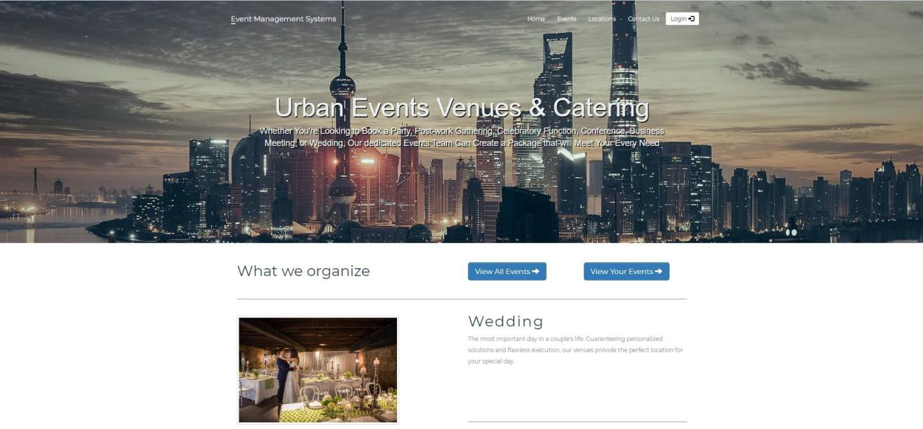

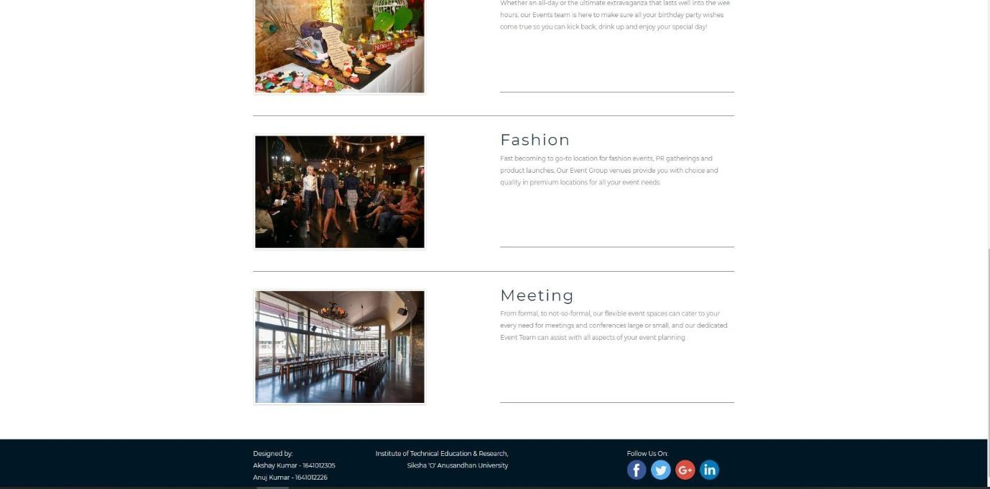**.!**

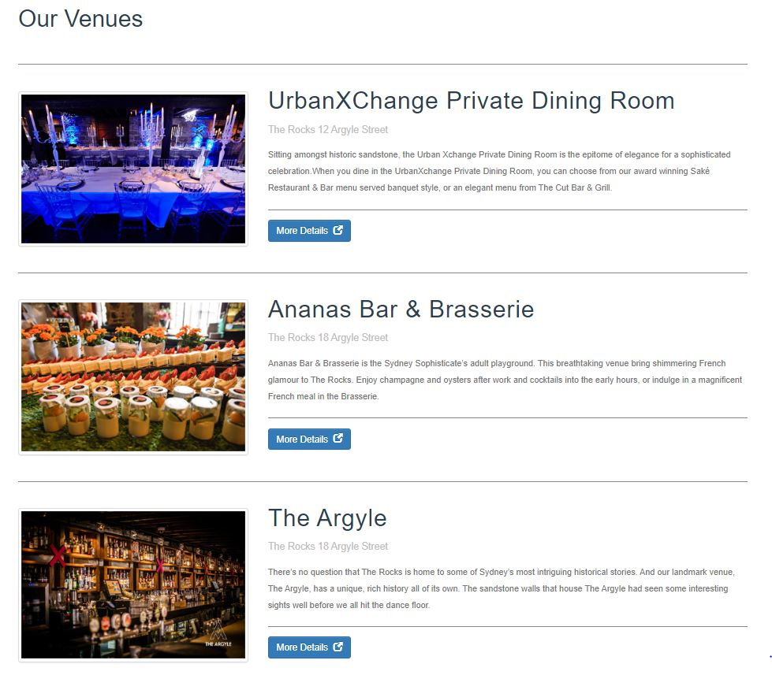

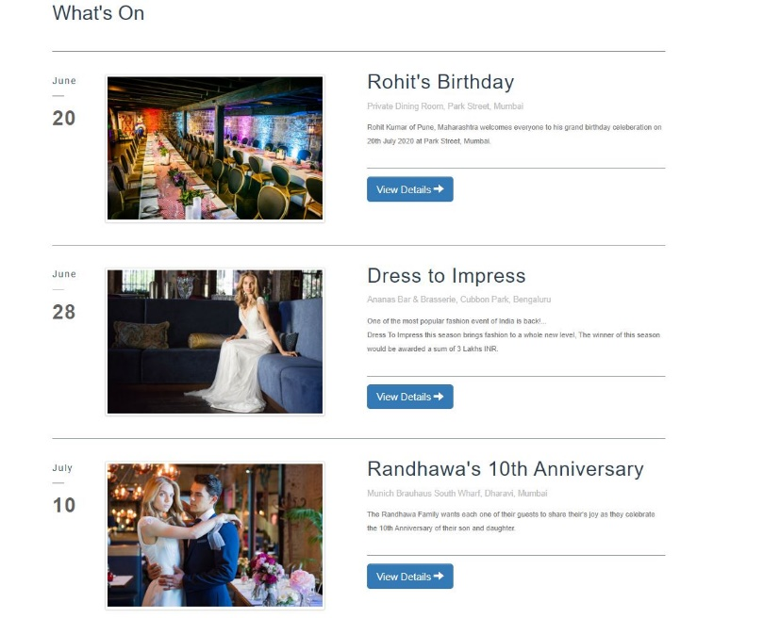

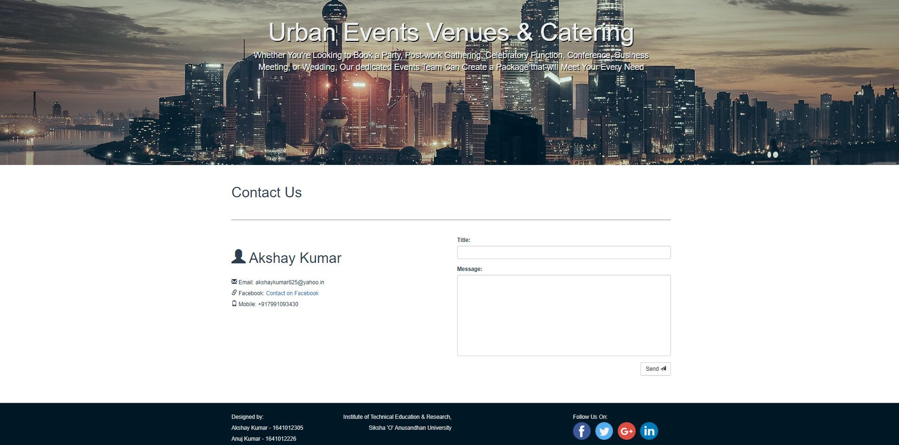

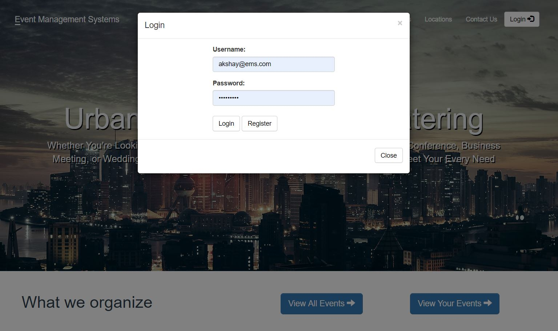

### TABLE & DATABASE DESIGNS

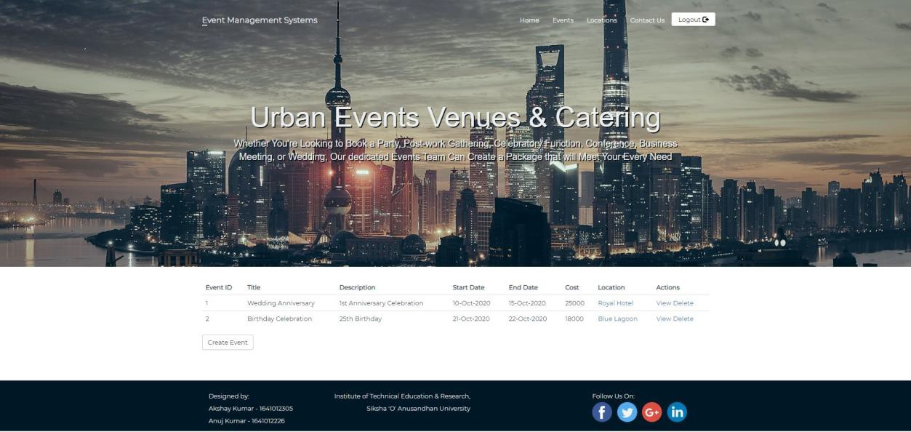

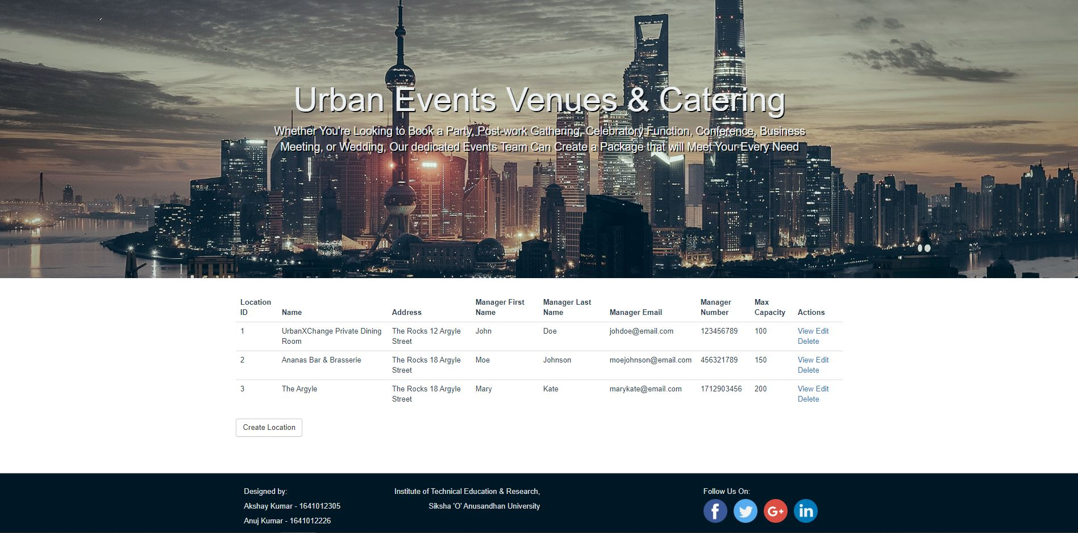

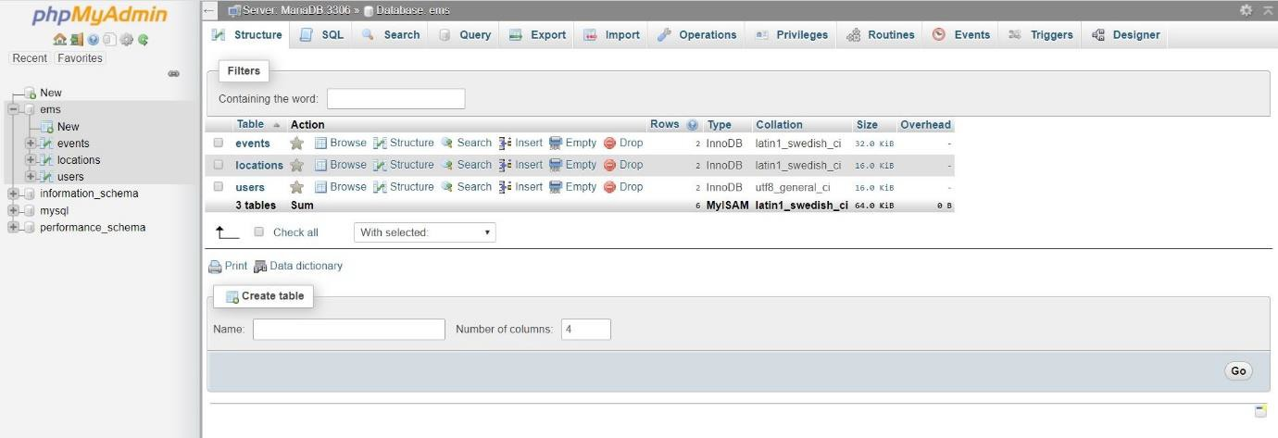

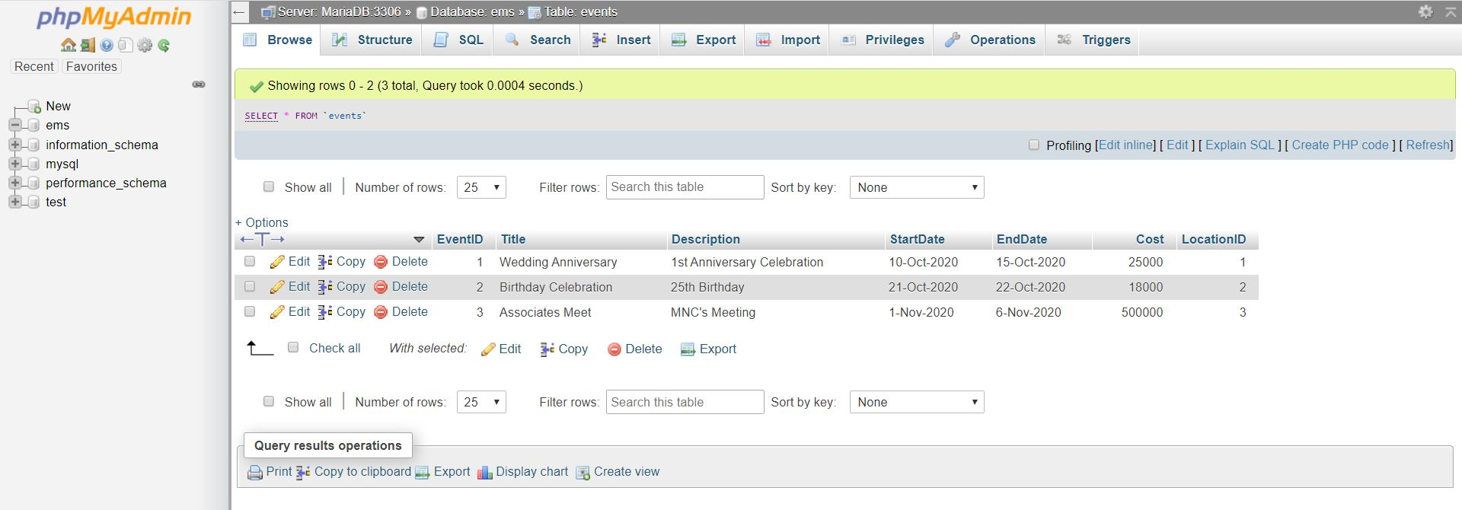

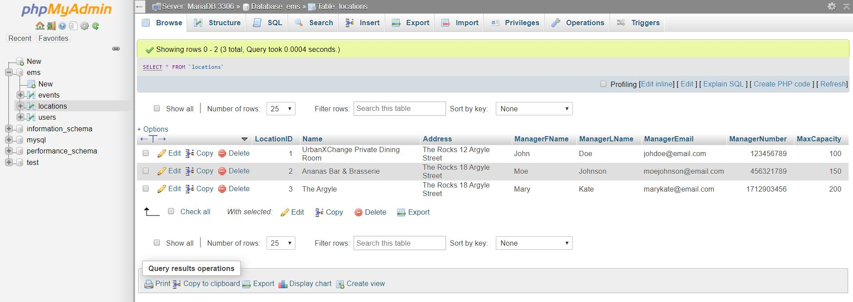

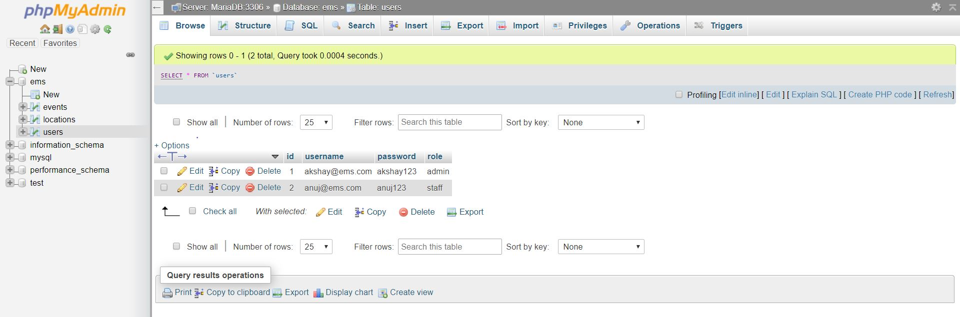

### SERVER & DATABASE CONFIGURATIONS

### 

### 

**PRACTICAL RELEVANCE**

The project with its practicality has a much greater significance towards the shifting of this human handled and maintained event management system towards a digital solution which reduces the human effort required for all the work that needs to be completed. This project is relevant to the event managers and customers or users and addresses why this project matters with such relevance to all the parties involved. This increases the communication between the event managers, organizers and the clients or the customers and provides a quicker solution to its masses.

In order for the event to be proper, planning and communicating are the two most important aspects of the successful event. Event management system can be a critical component of an MNC’s business operations. If the plan is for a webinar, concert, conference etc. the planning is completely done through the online site and the website helps coordinate all the important event intricacies. From selection of event location to the max capacity that can be handled is all being optional on the website for these kinds of management. Chaos and confusion are eliminated and the proper planning and execution is achieved.

Planning an event can sometimes be a very complicated task. From inviting guests, to ideal venue location and proper coordination and event to be held or organized successfully. Without event management system all these become hectic and planning consumes a lot time. However, with event management system, all the hard work can be done for us. Event management system simplifies this problem by implementing the software which handles the complexities easily.

**GLOBAL IMPACT**

The EMS project is our first primitive approach to change the current EMS sytem completely and for better.

The main global impact from this project would be the impact on the Event Managers and their Customers. This project aims to ease their manual work i.e. from the customers visiting the Event manager’s office (which might be closed on weekends or due to lunch breaks or any personal issue) to the manager’s hectic work of confirming and then booking the venue, then contacting each person individually for their work in the event (say lighting team, music team etc) which would easily take up a day or two.

So, the primary impact would be that the work which would take the manager a day or two is now the sole responsibilty of the EMS application and is managed automatically and the customer who might go to the manager’s office and find it closed or might try to find a better deal, visit another office (which most of them do) which can take them upto 2 to 3 days is now handled by our EMS application in just 10 minutes and operating 24x7.

Thus, it is more efficient, portable and cheap compared to the traditional system.

**LIFELONG LEARNING**

The EMS application helped us get to learn that noting is perfect, even not our ems application. We have to work continuously to improve the system more and more to make it better than the previous one.

Some, of the sectors like Event management, Crop management, Student management etc, are underlooked curreently. This might be due to less profit in these sectors, so there remain huge scopes of improvement in these sectors that might be due to old Software versions (Software), buggy code (Program), less number of server to address the client (Hardware).

From this application development we get to know and also revise our concepts on technologies like HTML, CSS, JavaScipt, PHP, Bootstrap, Jquery and SQL (MariaDB) and integrate them together to get a full working application.

The versions of technologies used were:

* HTML 5
* CSS 3
* JavaScript ES-4
* PHP 7.3.12
* Bootstrap 3.3.7
* Jquery 3.5.1
* MariaDB 10.4.10

**CONCLUSION**

Our EMS project is only a prototype approach to an Automated Event Management System. Many user-friendly coding practices have been adopted and applied. The System proves to be a very powerful package to fulfil most of the requirements of a customer willing to organize any event. The motive of the project is to boost the efficiency of the current EM systems which are lagging when compared with an autonomous one and thus this EMS aims to increase the overall revenue of the Firm using it.

The System has been designed such that it is very user friendly, from experts to naive customers can interact with the system easily, also a support page has been added to the EMS Website from where the user can directly contact the experts in case any issue arises.

**FUTURE SCOPE**

The EMS Project was developed to increase the efficiency of the whole event management process and is an upgrade to the traditional EMS syestem in every way. Although, the new EMS sytsem is a major upgrade to the traditional one, there are some future scopes for this project to make it even a better over itself.

Some of the future scope for this project are as follows:

1. The project currently stores the user-id and password in the Maria-DB database which is presently stored in plain text format which is risky for real-time use as if some malicious user get access to the database he can easily view the user-id’s and passwords.

Hence, the user-id and mainly the password should be encrypted and the website should be on https server.

1. The website currently uses get based requests for requests for some pages, although the personal pages are using post based request but it is better that all pages should use post based request as of now no private information uses get request but there is a security vulnerability that some url’s might get exposed to some malicious user and might be misused. Although, it is a minor flaw but is one of the important future work to be done

**REFERENCES**

1. Bonner, Marianne. ["Should You Buy Special Event Coverage?"](https://www.thebalancesmb.com/what-is-special-event-insurance-4151090). The Balance Small Business.
2. Capell-Abra, Laura. ["Events coordinator: The fifth most stressful job and why that matters"](https://www.citmagazine.com/article/1449482). [www.citmagazine.com](http://www.citmagazine.com).
3. ["What You Need to Know About New Degrees in Event Management"](https://www.bizbash.com/production-strategy/event-management-tech-tools/article/13233488/what-you-need-to-know-about-new-degrees-in-event-management) by Bizbash.com
4. Bowdin, Glenn; Johnny Allen, William O'Toole, Rob Harris, Ian McDonnell. Events Management
5. [Goldblatt, Joe](https://en.wikipedia.org/wiki/Joe_Goldblatt). Twenty-First Century Global Event Management
6. Bottorff, Tim (2018). ["A Hospitality Program Like No Other: A Brief History of UCF's Rosen College of Hospitality Management"](https://hospitality.ucf.edu/wp-content/uploads/sites/2/2018/05/Rosen-College-history-article-updated-for-new-website-2018-May-30.pdf)
7. Article by Joey Kendall on “Future of Event Management” [researchgate.com/event_management_system](https://www.researchgate.com/event_management_system).
8. Schivinski, Bruno; Langaro, Daniela; Shaw, Christina (2019). ["The Influence of Social Media Communication on Consumer's Attitudes and Behavioral Intentions Concerning Brandsponsored Events"](https://www.ingentaconnect.com/content/cog/em/pre-prints/content-ms-17-069_schivinski;jsessionid=bqgdq13sbfhl2.x-ic-live-03).
9. Ramsborg, G.C.; B Miller, D Breiter, BJ Reed & A Rushing (eds), Professional meeting management: Comprehensive strategies for meetings, conventions and events, 2008.
10. Stephanie Lavin blog on “Why is Event Management Software important?”, Slatwall Commerce,2015.
11. Event Management System by D Yogendra Rao: slideshare.net/DYogendraRao/event-management-system-24847429

**Mapping of POs and PSOs to Evidences**

|  |  |  |
| --- | --- | --- |
| **EVENT MANAGEMENT SYSTEM** | | |
| **POs and PSOs** | **Descriptions of POs and PSOs** | **Evidences** |
| PO1 | Apply the knowledge of mathematics, science, engineering fundamentals, and an engineering specialization to the solution of complex engineering problems. | Project Report: Synopsis, Page number 6 |
| PO2 | Identify, formulate, review research literature, and analyse complex engineering problems reaching substantiated conclusions using first principles of mathematics, natural sciences, and engineering sciences. | Project Report: Sections1,2, Page numbers 12-23 |
| PO3 | Design solutions for complex engineering problems and design system components or processes that meet the specified needs with appropriate consideration for the public health and safety, and the cultural, societal, and environmental considerations. | Website Demonstration |
| PO4 | Use research-based knowledge and research methods including design of experiments, analysis and interpretation of data, and synthesis of the information to provide valid conclusions. | Project Report: Sections3, 4 and 5, Page numbers |
| PO5 | Create, select, and apply appropriate techniques, resources, and modern engineering and IT tools including prediction and modelling to complex engineering activities with an understanding of the limitations. | Project Report: Sections 3, Page numbers |
| PO6 | Apply reasoning informed by the contextual knowledge to assess societal, health, safety, legal and cultural issues and the consequent responsibilities relevant to the professional engineering practice. | Project Report: Section 6, Page number |
| PO7 | Understand the impact of the professional engineering solutions in societal and environmental contexts, and demonstrate the knowledge of, and need for sustainable development. | Demonstration of app |
| PO8 | Apply ethical principles and commit to professional ethics and responsibilities and norms of the engineering practice. | Project Report: Declaration, Page and Similarity Report |
| PO9 | Function effectively as an individual, and as a member or leader in diverse teams, and in multidisciplinary settings. | Presentation |
| PO10 | Communicate effectively on complex engineering activities with the engineering community and with society at large, such as, being able to comprehend and write effective reports and design documentation, make effective presentations, and give and receive clear instructions. | Project Report and Presentation |
| PO11 | Demonstrate knowledge and understanding of the engineering and management principles and apply these to one’s own work, as a member and leader in a team, to manage projects and in multidisciplinary environments. | Presentation |
| PO12 | Recognize the need for, and have the preparation and ability to engage in independent and life-long learning in the broadest context of technological change. | Project Report: Section 6, Page number |
| PSO-I | The ability to understand, analyse and develop computer programs in the areas related to business intelligence, web design and networking for efficient design of computer-based systems of varying complexities. | Project Report: Section 3, Page numbers: and Website Demonstration |
| PSO-II | The ability to applying standard practices and strategies in software development using open-ended programming environments to deliver a quality product for business success. | Website demonstration |